**Project Design Phase-II**

**Technology Stack (Architecture & Stack)**

|  |  |
| --- | --- |
| Date | 31 October 2022 |
| Team ID | PNT2022TMID47261 |
| Project Name | Project – Plasma Donor Application Using Cloud Computing |
| Maximum Marks | 4 Marks |

**Technical Architecture:**

The Deliverable shall include the architectural diagram as below and the information as per the table1 & table 2

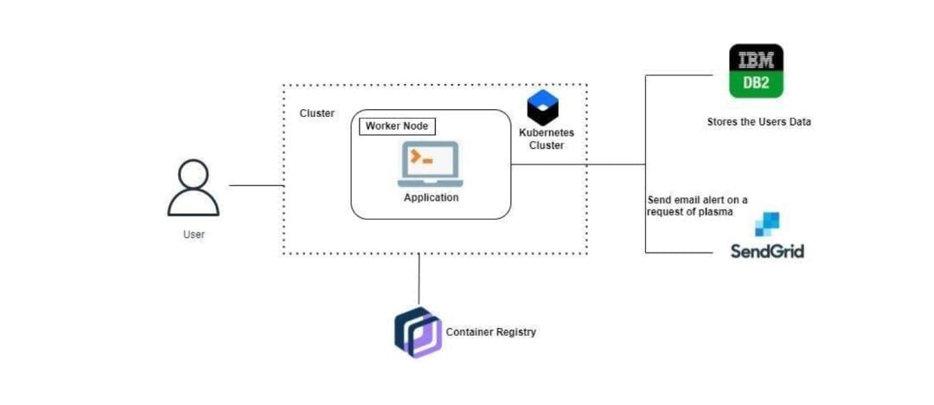

**Table-1 : Components & Technologies:**

|  |  |  |  |
| --- | --- | --- | --- |
| **S.No** | **Component** | **Description** | **Technology** |
|  | User Interface | How user interacts with application e.g.  Web UI, Mobile App, Chatbot etc. | HTML, CSS, JavaScript, Python, Flask |
|  | Register to website | The user can able to register in website and fill their details. The user details are Stored in IBM DB2 securely. | Flask app using Kubernetes cluster, IBM DB2. |
|  | Login to website | The user interact with the website to login into account. The user details are verified by comparing it with details stored in IBM DB2 | Flask app using Kubernetes cluster, IBM DB2. |
|  | Request for Donor/Register for donating | The user interact with the website to request for plasma Donor/Register for willing to donate plasma. | Flask app using Kubernetes cluster,IBM DB2. |
|  | Upload proof in website | The user can able to upload the vaccination certificate and other proofs. | Container register. |
|  | Cloud Database | Database Service on Cloud | IBM DB2, IBM Cloudant etc. |
|  | File Storage | File storage requirements | IBM Block Storage or Other Storage Service or Local Filesystem |
|  | External API-1(Email Alert) | To send email alerts to donor when a person requesting Plasma Donor. | SendGrid |
| 9. | Machine Learning Model | Machine Learning Model can be used for chatbot. | IBM Waston |
|  | Infrastructure(Server/cloud) | Application Deployment on Local System / Cloud | Local, Cloud Foundry, Kubernetes |
|  |  | | |

**Table-2: Application Characteristics:**

| **S.No** | **Characteristics** | **Description** | **Technology** |
| --- | --- | --- | --- |
|  | Open-Source Frameworks | Flask is an open source framework in python. Similarly, Docker is also used. | Flask, Docker |
|  | Security Implementations | Only registered users who have specific privileges has access to the website. | IBM DB2 |
|  | Scalable Architecture | 3-tier architecture, presentation tier, application tier, data tier | Python, IBM cloud services |
|  | Availability | The application can be available for user at any time. | Kubernetes, Docker |
|  | Performance | The application can handle multiple requests per second. | Kubernetes cluster, IBM |